Privileged delete is not working with RPS and Centera

We can not delete objects which are under retention and stored on the Centera with a “Privileged Delete”. We get the following message in the RPSA.

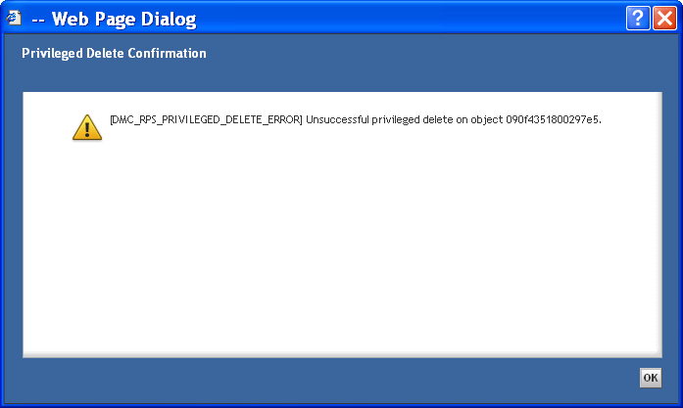

The retention period for objects on the Centera is configured through the attribute “i_retain_until” (see screenshot of the store).

In the Content Server Administration Guide is a section about “Forced deletion”. We have already configured the two options but there is no menu entry “Forced delete” nor can the object be deleted through a privileged delete.

Section in the Administrator Guide:
Enabling forced deletion in EMC Centera storage areas
Forced deletion allows a user to delete a document whose retention period is unexpired.
If the content is stored in an EMC Centera storage area, the user performing the forced
delete must connect through Documentum Administrator using a Centera profile that
grants the privileged delete permission. Content Server Fundamentals has a complete
description of forced deletions.
To allow a user with the appropriate repository privileges to perform a forced delete on a
Centera host, the profile must be available to the Content Server. The server sends the
profile to the Centera host when making the connection for the user. There are two
ways to make the profile available for use:
- You can include the full path to the profile file in the connection string specified in
a_storage_params property of the ca store object.
Instructions for setting the connection string in a_storage_params are found in
Defining the connection string , page 248.

- You can store the profile file in DOCUMENTUM/dba/config/repository_name/storage_
object_name_centera_profile.pea
where repository_name is the name of the repository and storage_object_name is the
object name of the ca store object.
For example, if the repository is named MyTest and the ca store object is named
MyCAStore, create a profile for the appropriate Centera storage system and copy it
to $DOCUMENTUM/dba/config/MyTest/MyCAStore_center_profile.pea.

Questions:
- Is a detailed guide available for the integration of RPS and Centera?
- Do we get a menu entry for “forced deletion” or is the functionality in menu entry “Privileged delete” included?
- Is the functionality of a privileged delete through RPS available when the objects are stored under retention on a Centera?

System Environment:

Documentum:
OS: Linux
Documentum Content Server 6.5 Sp2
Retention Policy Services 6.5 Sp2
RPSA 6.5 Sp2

Centera:
4-Node 500 GB G4
OS: CenteraStar 4.1
Governance Edition with EBR enabled

Documentum Store:
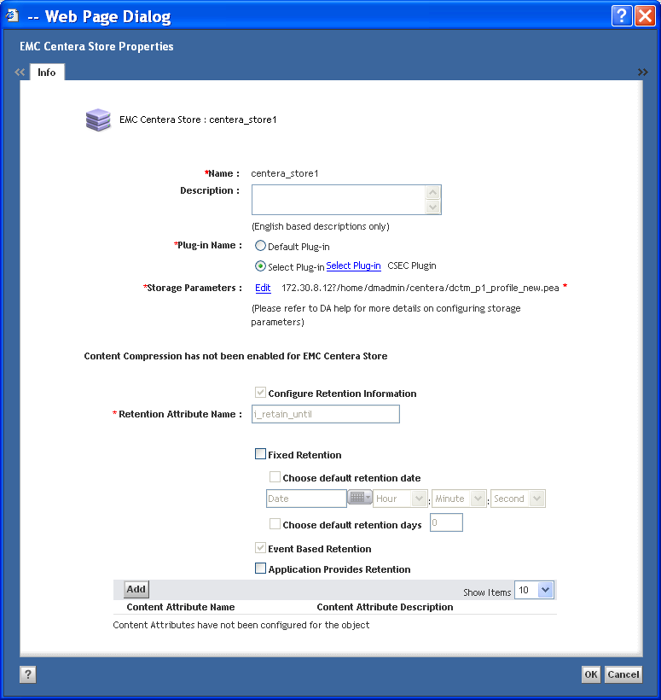

Documentum Type:
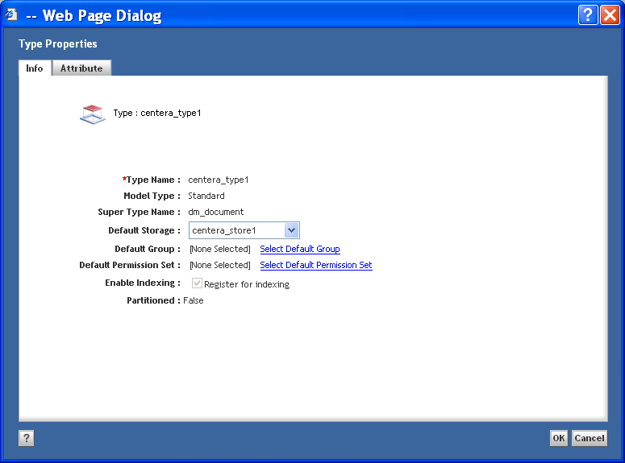

Retention Policy:
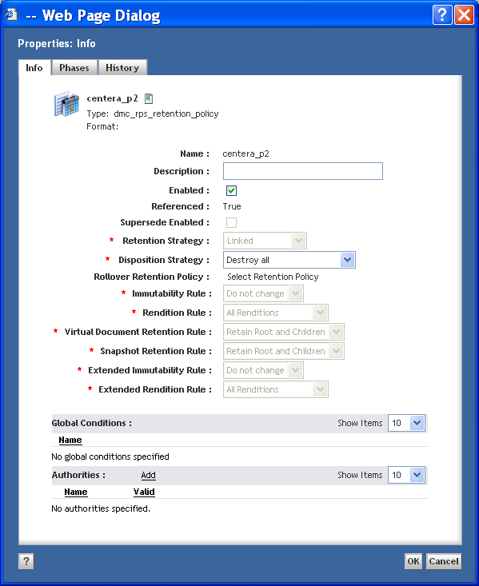

Centera Profile:
Config# create profile DCTM_P1_profile
Enable Profile? (yes, no) [yes]:
Set Data Access Capabilities (yes, no) [no]: y
Profile Type (access, cluster) [access]:
Home Pool [default]: DCTM_P1
Granted Rights for the Profile in the Home Pool [rdqeDcwh]:
Profile-Metadata Capability? (yes, no) [no]:
Set Cluster Management Roles (yes, no) [no]:
Profile Secret (prompt, generate, file) [generate]:
Issue the command?
(yes, no) [no]: yes
Establish a Pool Entry Authorization for application use? (yes, no) [no]: y
Please enter PEA file location: c:\centera\dctm_p1_profile.pea

Centera Profile Details:
Config# show profile det DCTM_P1_profile
Centera Profile Detail Report
------------------------------------------------------
Generated on Donnerstag, 17. Juni 2010 09:18:45 CEST

Profile Name: DCTM_P1_profile
Profile Enabled: yes
Profile Secret Persistency Format: obfuscated
IP Restrictions: <no restrictions>

Data Access Capabilities:
Profile-metadata Capability: off
Home Pool: DCTM_P1
Profile Type: Access
Cluster Mask: rdqeDcw--h

Granted Rights in Application Pools:
Pool Name Pool Mask Granted Effective
----------------------------------------------------------------------
DCTM_P1 rdqeDcwh rdqeDcwh rdqeDcwh
----------------------------------------------------------------------

Scratchpad Pool Mapping: -
Active Pool Mapping: -

Cluster Management Roles: none

